

Department of Computer Science and Engineering

Requirement Specification of

***Fresh Food: From land to hand***

***(An E-Commerce Site for Agricultural Products)***

Course Name: Software Engineering

Course Code: CSE411

Section: 3

Submitted By:  
Abdullah Al Asif (2016-2-60-066)  
Md. Sabbir Hasan(2016-2-60-110)  
Tasnova Bintee Taher(2016-2-60-023)

Submitted to:  
Md.Mohsin Uddin  
Lecturer  
Department of Computer Science and Engineering

Summer19||August 4

**Introduction:**

Bangladesh is a land of agriculture and here major part of the population earns their livings by means of agriculture. So, country’s development mainly depends on agriculture and farmers. But matter of sad that, these farmers are not getting the proper value of their crops. Most of them are commonly cheated by some third party fraud people. For this reason, they are having a life full of sufferings and struggling with poverty. As a result the development of the country is highly obstructed. Also the dream of making the country digital is rarely possible if we left out in considering these farmers. Now, in order to solve this problem, considering the development of the country and the lifestyle of the people, we must need to ensure that farmers do not get cheated anymore. They get the proper value of their products and payment in time. In that case our project will be highly beneficial for them. By using our project they will be able to sell their product directly to buyers so there will be no chance to get cheated by middleman. Not only that, city people will also benefit through it. How? It’s known to us that, the people of city can rarely buy fresh agricultural products. Now, by using our application they will be able to get fresh products directly from farmers. So, we can see both the farmers and the people of city will greatly benefit from our project. As a result the economic situation of the farmers and the health factor of the city people will increase. Not only that, it will also help to resolve the economic problem of our country. Besides the motto of our government is to make the country digital and in order to do that people from all aspects should be habituate in basic technology. From that aspect, our project is going to be a solution for this problem. Moreover the payment system of this generation is changing from money into card and other online payment gateway system. If we don’t cope with this system, we may face some great issues regarding payment system in near future. Hopefully, our project will work on that area too and will demonstrate a healthy payment system for all. So, we can see that our project will be  fruitful for the people of village and city, it’s will help to make the country digital, it will help to cope with the new generation payment system and so on. There for the importance of our project knows no bounds.

**Objective:**

The main objective of this project is to build a platform for farmers to sell their product and  
track the sale. This platform is flexible which can maneuver the customer-farmer relationship in  
an effective manner. Farmer will get unique interface where they can avail everything right  
from learning to the market information. This website will act as unique and secure way to  
perform agro-marketing.

**How the system works:**

* At first each person need to register (without admin) himself/herself as a customer or a  
  farmer or a dealer for accessing the user’s necessary information. Each user requires a  
  unique username or email Id and password to register in the website.
* Admin/Farmer need to login to the system to operate the system. Admin/Farmer has an  
  individual or unique login user id and password. Through this user id and password  
  admin/farmer can login to the system.
* A customer can select a product for buying and add to cart. Customer also can pay online  
  or cash on delivery.
* Admin can update all the information of the registered users. Any registered member can  
  be deleted by the admin. And also view all order and can download.
* Admin can update the category list of the product. An admin can edit or delete a category  
  from the product category list. Admin can also insert a new category menu in the  
  category list. Admin can also insert product with price and quantity.
* Farmer can add product with price. After add product farmer can edit, delete and publish  
  of product. When farmer add product and publish then customer can buy the product  
  from the web page.
* Dealer gets the product from website with low price. Dealer should be register for this  
  service.

**Non-Functional Requirements:-**

* SQLinjection attack free login.
* Least possible response time and space
* Environment friendly
* Integrated data system
* Safe and Secure
* User friendly
* Maintain ethical issues properly

**Functional Requirements:-**

**Buyers Panel**

* can edit own profile
* can order / cancel order
* select quantity / update quantity
* can review to seller
* online payment
* location based search ( Mango of Rajshahi, Rice of Barisal)
* view sellers uploaded product

**Sellers Panel**

* Can edit own profile
* Upload product’s image , price and quantity
* Review to buyers
* Get payment by online

**Administrative Panel**:-

* access both buyers and sellers data
* modify all data
* provide standard price list

**Common Features:-**

* Login and Register
* Password update and recovery
* View site

**Technical Terminology:**

To implement the project, some open source tools will be used such as Eclipse, XAMPP,  
Tomcat server, Servlet etc. The web programing language used to implement this project are HTML (Hyper Text Markup Language), CSS (Cascading Style Sheets), JavaScript and PHP.

**Module:**

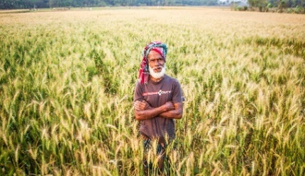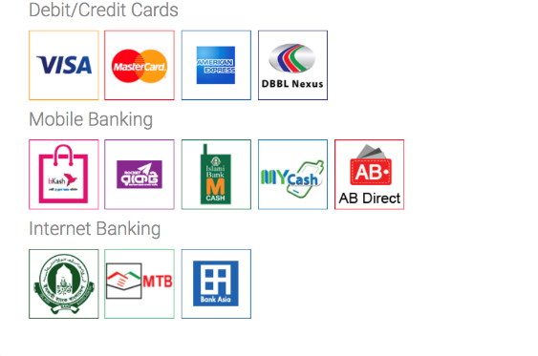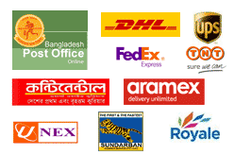

Fig: Block Diagram

**Database**

Upload

**Activity Diagram :   
  
  
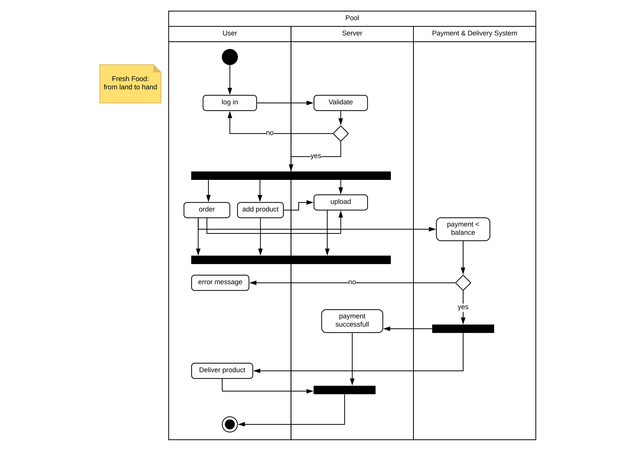**

**Figure : Activity Diagram**

**Class Diagram :   
  
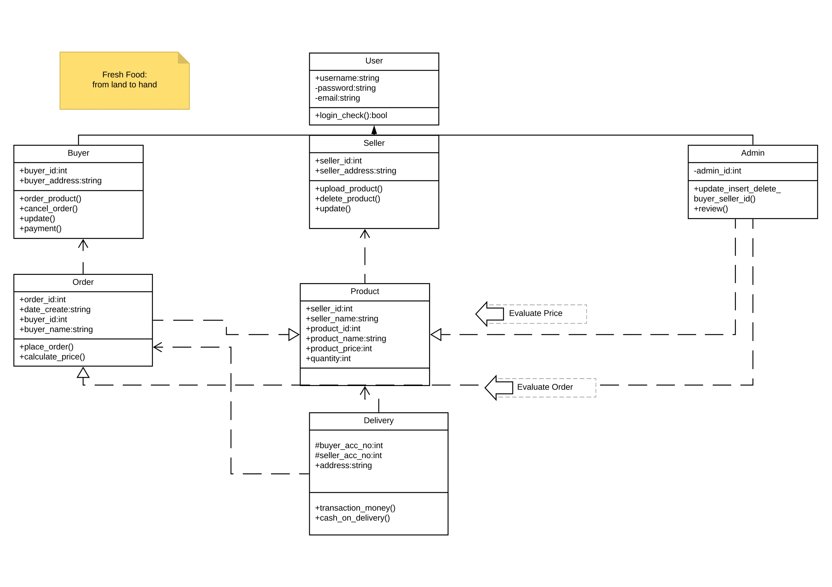**

**Figure : Class Diagram**

**Use Case Diagram :   
  
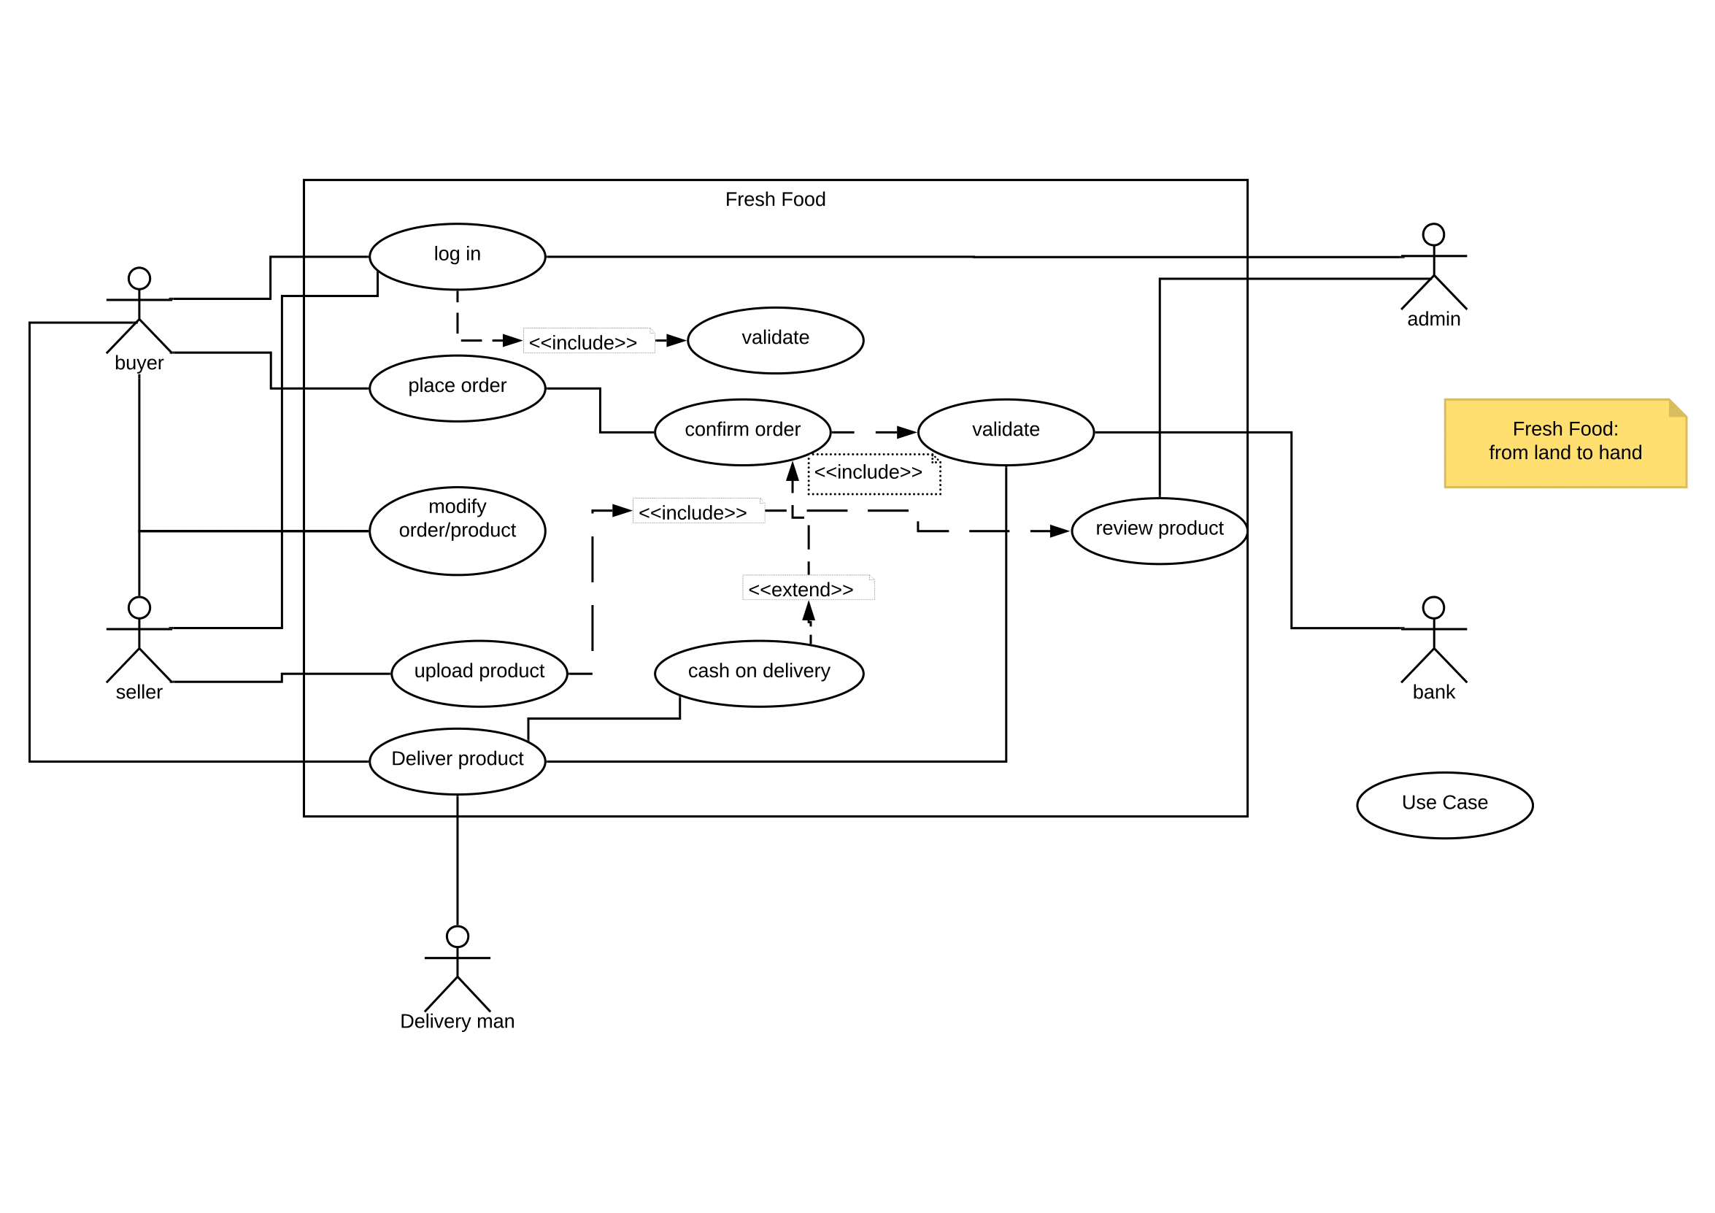**

**Figure : Use Case Diagram**

**Sequence Diagram :   
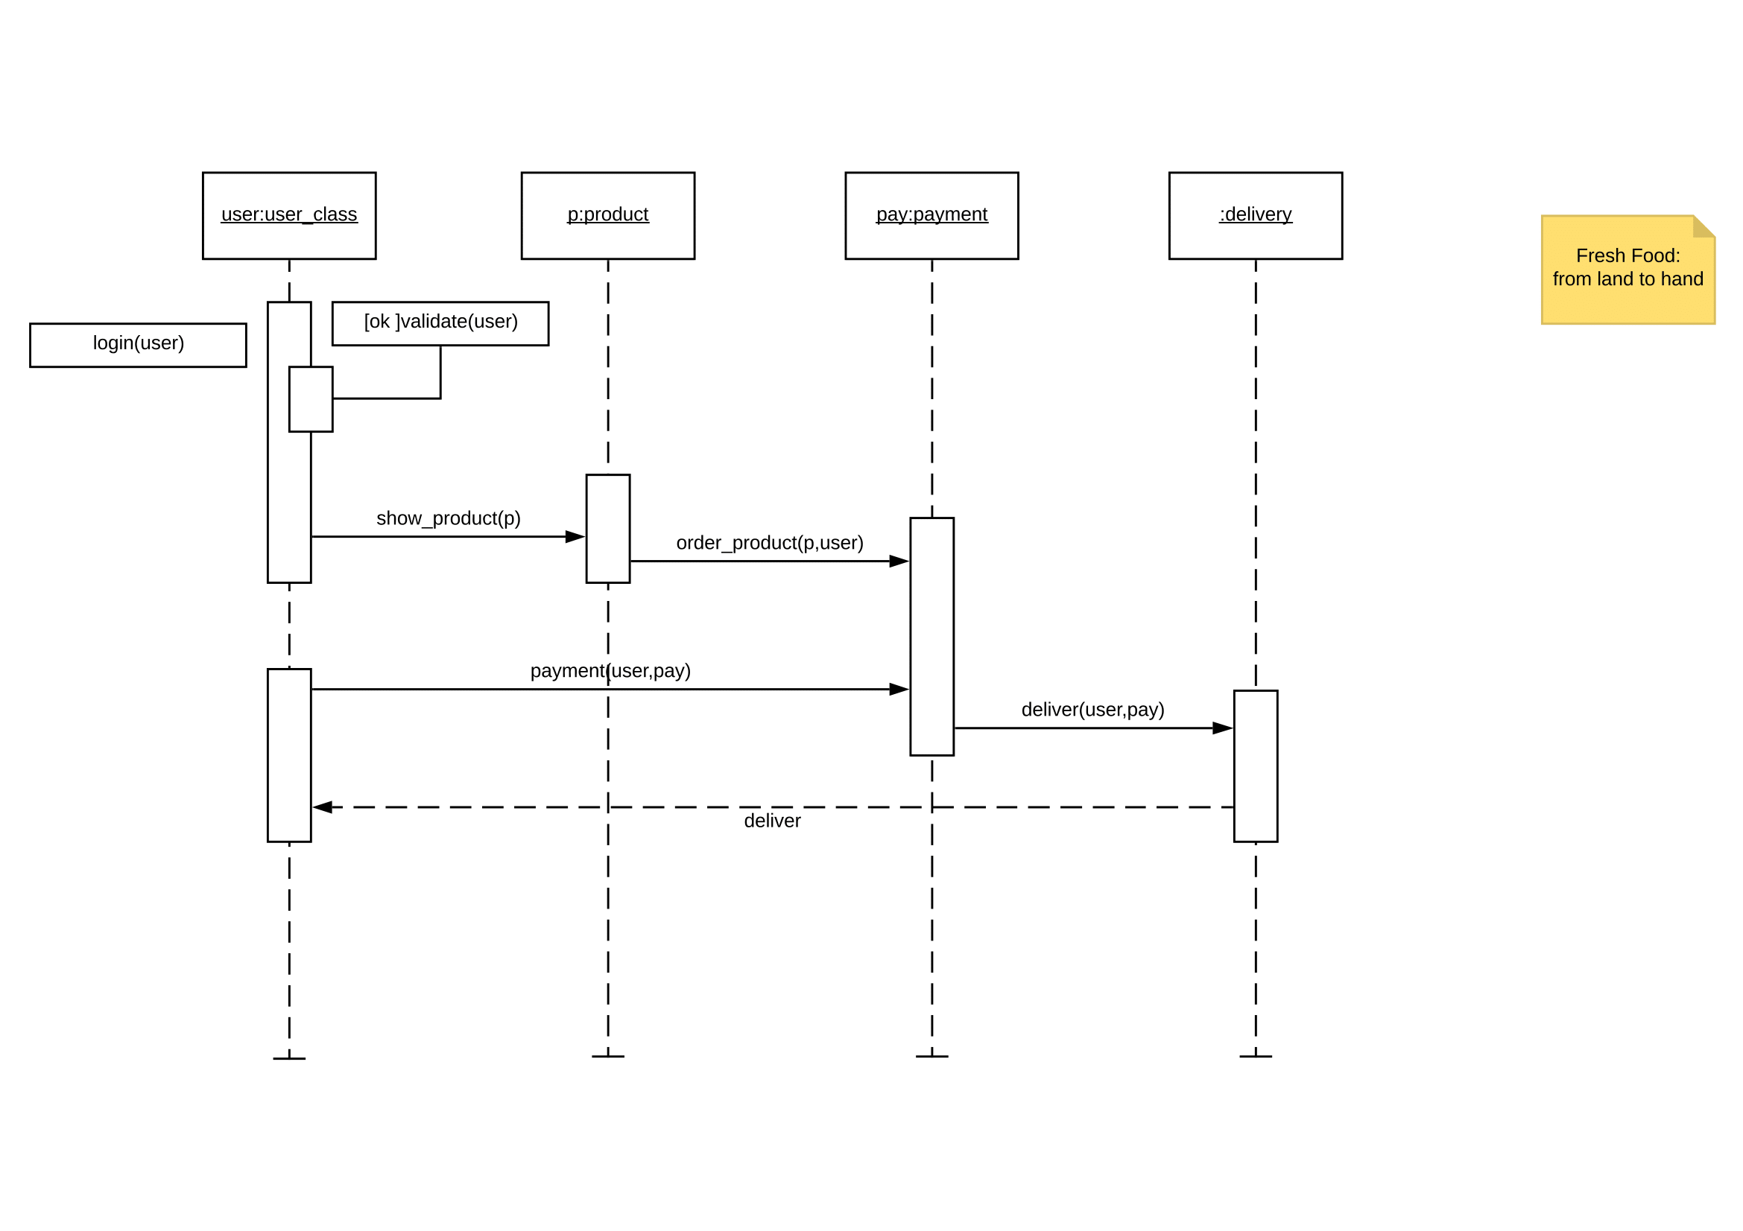**

**Figure : Sequence Diagram**

**ER Diagram :   
  
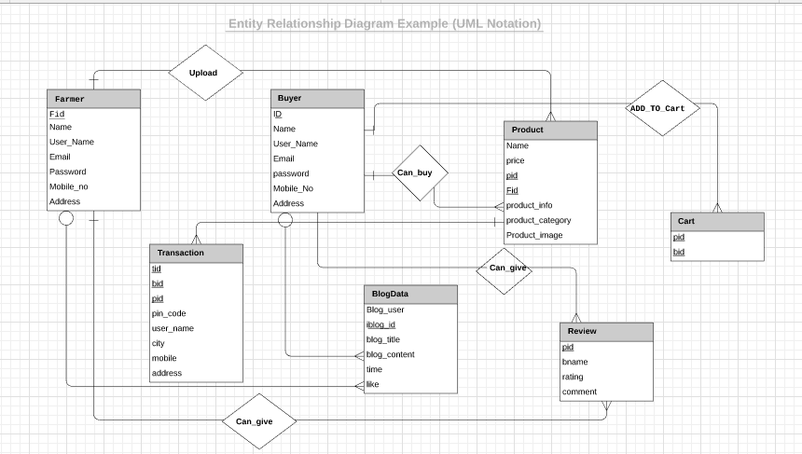**

**Figure : ER Diagram**

**GUI Screenshots :   
  
Home page :   
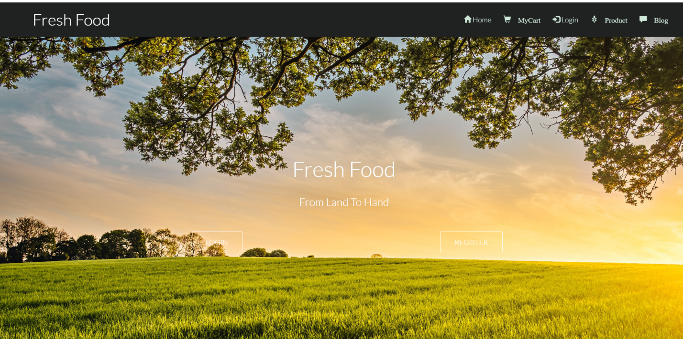**

**After login :** Here , user is Asif.

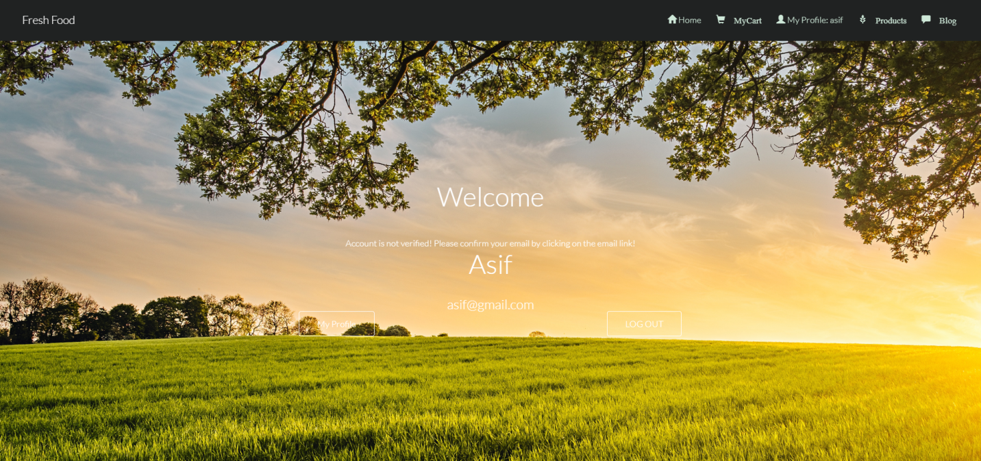

**Farmer’s Profile :** Here, farmer can upload product and logout from profile.

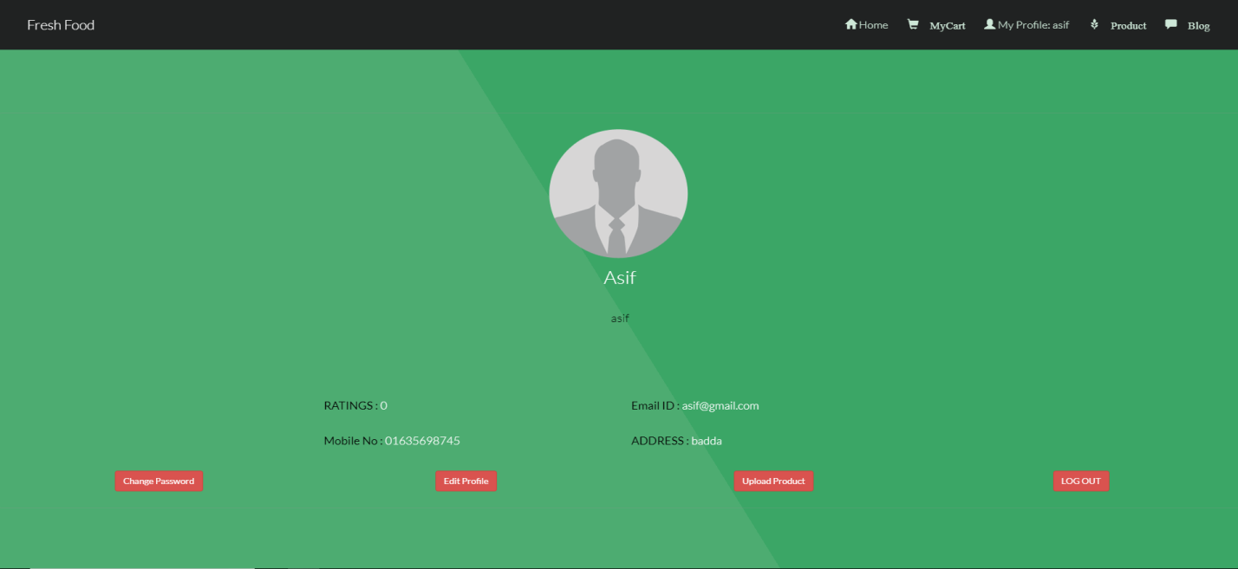

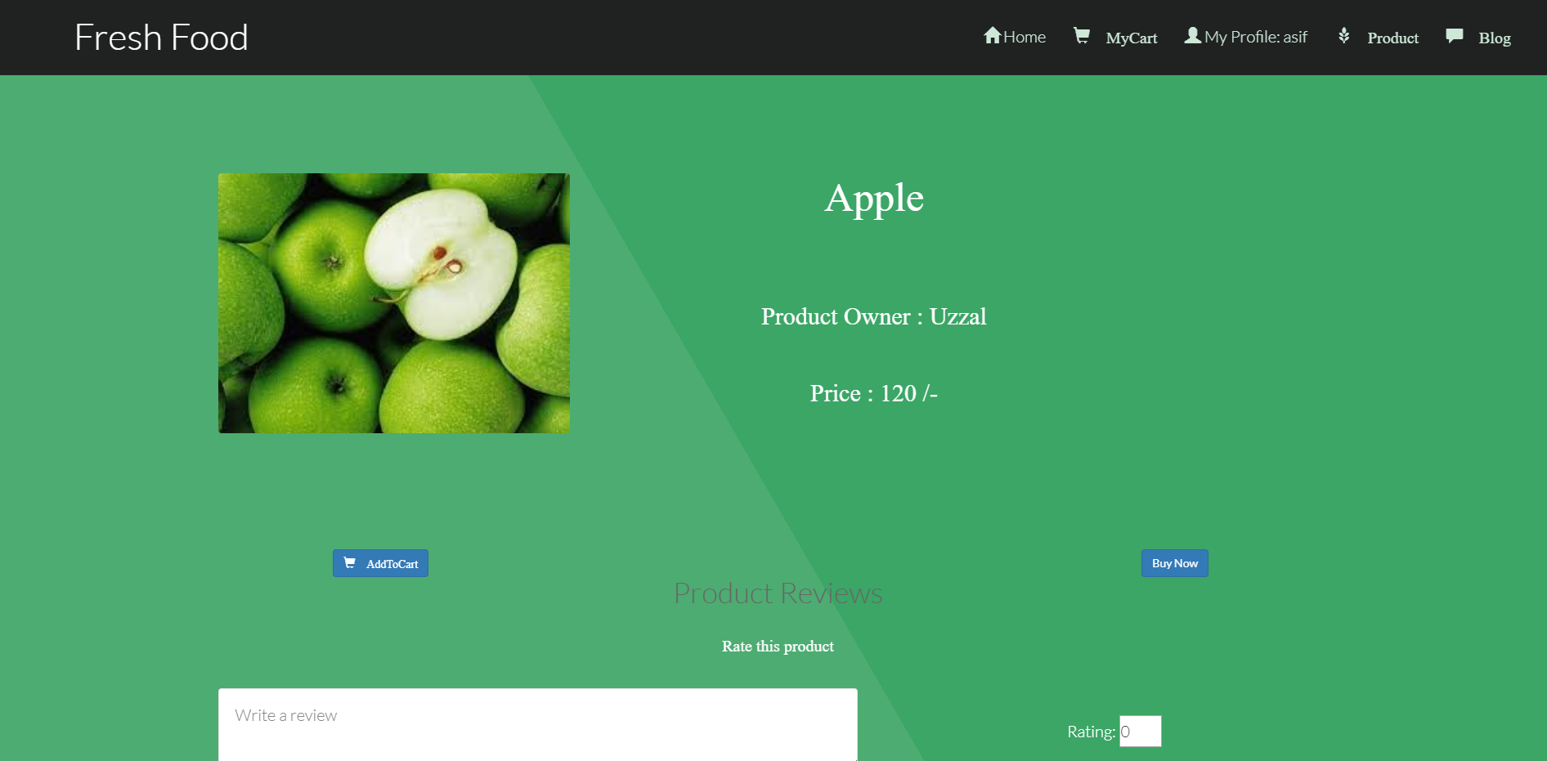

**Cart View :**

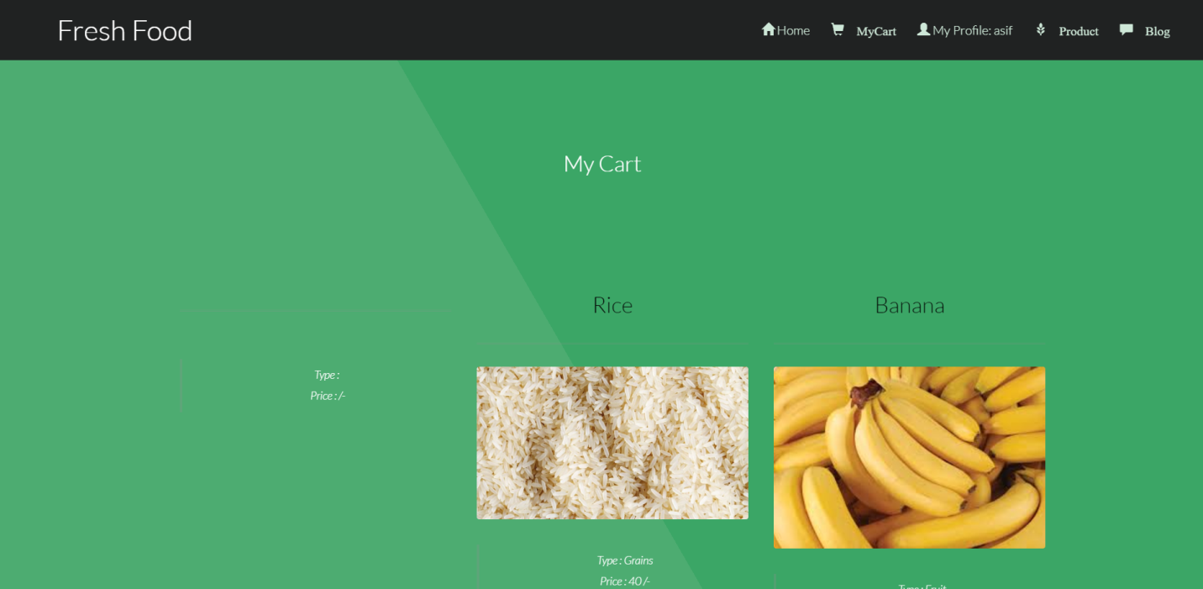

**Blog view :**

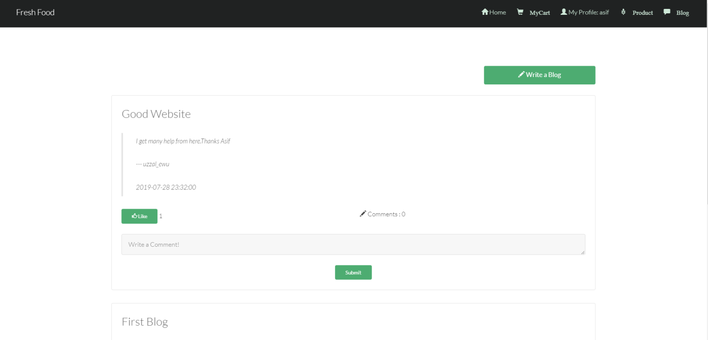

**Limitations :**1**.** No 3rd party like uber , pathao or any delivery service is not connected to our system.   
2. Admin panel can not fully control the whole system.  
3. Payment system like bkash, card etc is not used here.   
4. Buyers or farmers can not update their profile.   
5. Buyers can not cancel order.   
6. Security system is not much strong.   
  
  
**Future Work :**   
1. Delivery system will be added in this system .   
2. Admin will have the whole control to monitor the system.   
3. Payment system will be added .   
4. Buyers or Farmers can edit their profile.   
5. Cancel order feature will be added here.   
6. Delete product from farmer’s profile will be added.   
7. Strong Security service will be provided.

**Conclusion:**

The “Fresh Foods: From land to hand” will be successfully designed and developed to fulfill the necessary requirements, as identified in the requirements analysis phase, such as the system will work with very much user friendly. The old manual system was suffering from a series of drawbacks. The present project will have been developed to meet the aspirations indicated in the modern age. Through the developed project, anyone can visualize the effectiveness and efficiency in the real life. It is very helpful for computerization or doing automation of a personal information management system. This program helps reduce the manual method and stress which is done by a person and that is time consuming and lengthy process. With this application user’s information are stored very efficiently in a secured database. Trend of information improvement in the generation has improved the quality and services of human operation just as the case of this application for job services has reduce the mobility rate of human and improve their standard of database storage.